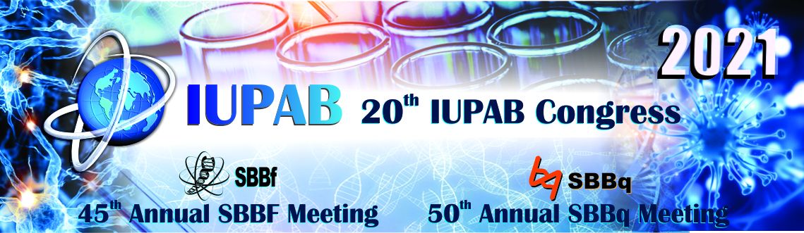

São Paulo, May 20th, 2021

To

IUPAB Committee

On behalf of the Brazilian biophysics and biochemistry communities, we are honor to announce the progresses in the organization of the 20th IUPAB Congress, to be held from 4th to 8th of October of 2021 in the virtual format.

We aim to offer a broad international overview of research frontiers and recent developments in biophysics and biochemistry. We have organized an outstanding program with contributions in the form of keynote lectures and symposia, as well as oral and poster presentations. 10 key note speakers, two of them Nobel prize winners, and 24 symposia will cover a wide range of interests in biophysics and biochemistry. Over 80 speakers (29 from North America, 27 from Europe, 23 from South America, 8 from Asia, Oceania and Middle East) from all continents (24 countries) in a male:female rate of ~ 2:1 have accepted to deliver lectures. Chairs will also select 28 oral presentations from the submitted abstracts. There will be two specific periods for poster presentations and we are expecting more than 500 poster presenters.

The presence of leading scientists among the invited speakers will certainly contribute to create a very rich scientific environment, which we hope will also allow for bringing together the best of Science in biophysics and biochemistry. We have contracted the most advanced platforms for virtual conferences to allow a very interactive experience during the event.

We are also working hard to involve young scientists (YS) in the event. An ongoing webinar Series (The YS Webinar Series) comprises 10 webinars between May and September 2021, covering different areas of biochemistry and biophysics. The program includes 10 senior speakers (8 males, 2 females) and 32 young scientist participants (15 males, 17 females) from 14 countries and five continents (Argentina, Belgium, Brazil, Hungary, India, Iran, Italy, Netherlands, Nigeria, Portugal, Spain, South Africa, UK, USA). The YS speakers were selected by an evaluation committee from 146 applicants from all over the world and leading senior speakers were invited and happily agree to participate. The webinars will comprise a 40 min talk from a leading scientist in the field plus 3-4 short talks (15 min) from young scientists (Postdocs, PhD students). Registration to the YS Seminars is free of charge. The Webinars will be hosted in the Zoom platform and recorded for late view in the Societies web channel, and the YS participants will have full waiver of the registration fee in the IUPAB congress.

With resources provided directly from IUPAB, we are organizing a sponsorship award for helping 50 enrolled PhD students to participate in the IUPAB congress (<http://iupab2020.sbbq.org.br/interna-537/iupab-fellowships>). We will also organize the 24th Young Talent Award in Life Sciences promoted by SBBq and Cytiva (<http://www2.sbbq.org.br/jovemtalento/>) and a poster award.

SBBqExpo, which is an exhibition hall for companies and sponsors that usually is one of the greatest aspects of our past congresses, will be held during the 20th IUPAB Congress and we are optimistic that it will likewise be a success in the virtual format.

To conclude, we are certain that the congress will be an unforgettable event and we look forward to welcoming you to the virtual 20th IUPAB!

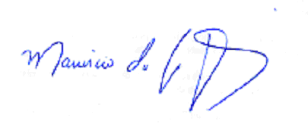Rosangela Itri

Mauricio da Silva Baptista

Chairs of the IUPAB-SBBf-SBBq Congress