Dear EBSA members,

Can I draw your attention to the following Faraday Discussion meeting:

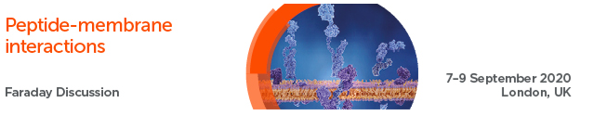

**Royal Society Faraday Discussion meeting:**[**http://www.rsc.org/events/detail/37143/peptide-membrane-interactions-faraday-**](https://eur02.safelinks.protection.outlook.com/?url=http%3A%2F%2Fwww.rsc.org%2Fevents%2Fdetail%2F37143%2Fpeptide-membrane-interactions-faraday-discussion&data=02%7C01%7Cp.oshea1%40lancaster.ac.uk%7C5f0b7e320a1c4ade838d08d74be7b1fe%7C9c9bcd11977a4e9ca9a0bc734090164a%7C1%7C0%7C637061330813504793&sdata=oE9mBwdGZ6FUg2XFj7ypKNZGiiIEAgYKxNR2CX%2FpRpQ%3D&reserved=0)

**Please note that the deadline for submission of Oral Abstracts is Monday 2nd December 2019.**

The meeting will cover all aspects of how peptides as macromolecules interact with membranes; from basic theoretical considerations embodied in computational models, wet experimental studies of model systems through to living membranes and synthetic biology applications. Thus, the questions we will address bridge the divides between aspects of the fundamental physical chemistry of macromolecular polyelectrolytes and cell biology as well as drug development and synthetic biology

We believe that a FD meeting will be a great format to consolidate and develop this entire field, with the unique dialectical emphasis of the Faraday meeting promoting a level of focus on key questions whilst allowing a sense of context to be retained that other meetings do not meet.

We would like strongly to encourage you to submit a paper for consideration for presentation at the meeting. The nature of the meeting format requires pre-circulation of the papers to the participants for discussion at the meeting. We are keen, therefore, to ensure the highest quality of science is represented at the meeting. Following the meeting the papers and the discussion will be collected together into a single volume (as with previous meetings eg : <https://pubs.rsc.org/en/content/ebook/978-1-84973-688-6> )

We do hope you will be able to come along.

Very best wishes,

John Seddon, Imperial College London.